 | 14.1.12 Editors - Video Sequence Editor - Header - Scene Menu
Table of content
Text menu 1
Adjust Timing 1
Toggle Active Scene Strip 1
Play Master Scene 1

Text menu

Of interest when you deal with more than one scene. Activate the Sync button.

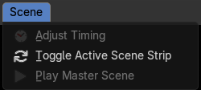
Adjust Timing
Adjust the timing of the active scene interactively.

Toggle Active Scene Strip
Updates the active scene to active scene strip.
If synchronization timeline in Sequencer is not set, this toggles the current scene to active scene strip in the sequencer.

Play Master Scene
Starts or stops the playback of synchronization timeline.

